
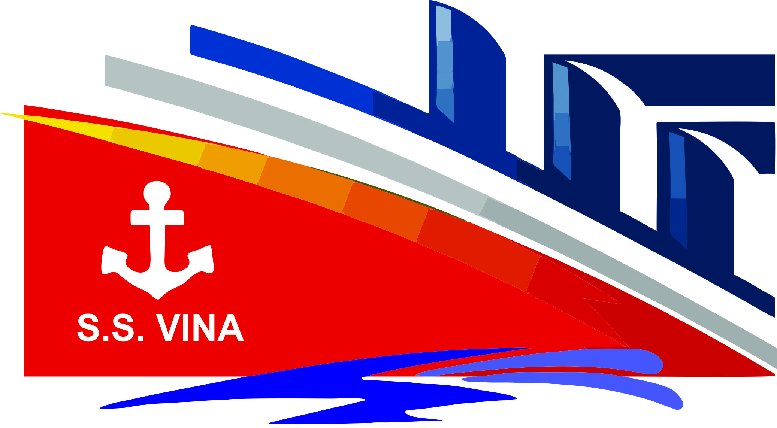
Thank you

S.S. VINA Cruise Sponsor
Pat & Mike Biber

Casino Sponsor
Dr. Gordon Niles Orthodontics

Entertainment Sponsors
Drs. Don & Sandy LaTurno
Brighton Family Dentistry
Fowlerville Family Dentistry

Windjammer Dinner sponsor
1st National Bank

Promenade Sponsor
Vanston O'Brien

Welcome sponsors
Champion Automotive Group
Dr. Carl & Diane Mueller

Ice sculpture Sponsor
Ida Bergsma

Schooner Bar Sponsors
Root Canal Specialty Associates
Chase Dental & Medical Supply
TNT Orthodontics
Comerica Bank
Ron & Sue Measel
Mezzanine Deck Sponsor
Ciao Amicis

Confection Table Sponsors
Diamond Home Inspectors Landry Electric
Rehmann CPA's & Consultants
Drs. Robert & Christine Love
Dr. William Horal
Belle Ami
Dr. Sam Allen
Wilson Marine
Ronda Beach, RDH
LDDS
McMillan & Associates
The Huntington National Bank

Media Sponsors
George Moses Co. / The Marketeer
Greater Brighton Area Chamber of Commerce
WHMI
G1NBC
BigPDQ

Cruise Committee & volunteers!

Dinner Cruise Committee
Ida Bergsma
Lynne Fialkowski
Carl Gilgallon
Linda Grischy
Mary Hamway
Lisa Izant
Dr. Sandy LaTurno
Dr. Christine Love
Jean Petersburg
Michelle Vasilco

Dinner Cruise Volunteers
Dr. Gwynne Attarian
Ronda Beach
Corbin Charder
Jessica Davis
Nick Gronow
Darlene McManus
Jeannie McMillan
Jerry Piekarz
Vicki Piekarz
Tetyana Richason
Barb Terry

Casino Cruise Volunteers
Mark Haas
Alicia Branstrom
Kathy Cooper
Jim Cooper
Bill Edwards
Debbie Edwards

cruise professionals

Cruise Photographer
Kay Beech

Cruise Sound Specialist
Carl Gilgallon

Cruise Florist
Bonnie Sandberg and Four Seasons Florist

Cruise Casino Manager
Mark Haas, Premier Dental

Cruise Entertainer
Michael Mode

Cruise SPA
Dr. Adam Rushford, Hands on Health Chiropractic
Michele’s Salon
Chelsea Holladay

Cruise EMCEE
Dr. Brian Petersburg

Cruise cake
Jennifer DeMott

Ice Sculpture
Pat Srock

Auction Donors

Angelina’s
Art in Bloom
Belle Ami – A Nail Salon
Big League Haircut
Bink and Babs
Breathe Salon
Bye-Bye Pain Mobile Lasers
Canopy Bottle & Gourmet Shoppe
Carriage House Designs
Chain of Lakes
Cooper and Binkley
CW Interiors
Deb’s Forever Quilting
Diane Evans
Diamond Home Inspections
Dr. Brian & Jean Petersburg
Dr. Christine Love
Dr. Don LaTurno
Dr. Robert & Margaret Adams
Dr. Sandy LaTurno
Dr. Tom & Mary Hamway
Drs. Ruskin & Krishnan
Everfit Studios
Fancy Nancy's Stained Glass
FAO Jewelers
Gary Brewer
Gia’s Salon
Hair by LaClair
Hamburg Fitness Center
Ida Bergsma
Imperfections
Jeff & Barb Terry
Jewelry Depot
Jim & Peggy Anthony
Judy Waggoner
Karen Radtke
Lakelands Golf & Country Club
Landry Electric
Lawrence Autobody
Linda Grischy
Linda Peckens
Lisa & Eric VanDerhoof
Luna Salon
Mary Clark
Michael Glenn Monroe
Michelle Vasilico
Michele’s Salon
Oak Pointe Golf Club
Ore Creek Jewelers
Peggy Brewer
Pure Barre Brighton
Rendall’s Sci-Clean Carpet
Real Irish
Ronda Beach
Sassafras
Senator Joe Hune
The DIO
Thompson Art Glass
Timber Trace Golf Club
Two Brothers Coffee
Two Your Door Drycleaners
Zulu Nyala

Gift Basket Donors

Brighton District Library
Brighton Family Dentistry
Dr. Gordie & Sandi Niles
Dr. Gwynne Attarian
Dr. Jill Doan
Dr. Leon Siomka
Dr. Matt Matuszak
Dr. Sam Daniels
Dr. Ulla Crouse
Drs. Christine & Robert Love
Drs. Eick & Birchmeier
Drs. Fuhst Wylie & Kahn
Drs. Sarah Carrico & Dana Radtke
Dr. William Metz
Dr. John Keeton
Enzo’s Catering
Fowlerville Family Dentistry
Midway Dental
Modern Dental Lab
TNT Orthodontics

CASH DONORS
Dr. Allen
Dr. Gywnne Attarian
Anne Belser
Dr. Fred Bonine
Dr. Ryan Bresbois
Gary & Peggy Brewer
Dr. Michael & Marygrace Britt
Kenneth & Keven Burchfield
Dr. Doug & Danielle Cabell
Steve & Kathy Davis
Joe & Theresa DeMaria
Dr. Paymon Dorri
Paul & Cathy Edwards
Lynne Fialkowski
Richard & Mary Galbally
Rudy Gaza
Carol Griffith
Griffith Realty
Linda Grischy
Mark Haas
Hon. Michael & Vivian Hatty
Elizabeth Hembree
Chelsea Holladay
Matt & Marsha Ikle
Drs. Don & Sandra Laturno
Chad Lloyd
Drs. Bob & Chris Love
Kelly Luck
Robert Lulgjuraj
Pamela McConeghy
Jeannie McMillan
Paula Millis
David & Patricia Moore
Dr. Carl & Diane Mueller
Jerry Perzyk & Carolyn Mahalak
Dr. Ron & Mary Jo Paler
Dr. Brian & Jean Petersburg
Kati Petersburg
Cindy Pine
Dr Adam Rushford
Dr. Tom & Emily Sulfaro
Dr. Neil & Suzanne Thomas
Valerie Tillstrom
MaryAnne Turgyen
David & Lori Walters

Restaurant Donors

Alexander’s
Bagger Dave’s
Big Boy
Biggby Coffee - Howell
Bob Evans
Brewery Becker
Brighton Bar & Grill
Brighton Dairy Queen
Buffalo Wild Wings
Captain Joe’s
Champ’s Pub
Ciao Amici’s
Coney Joe’s
Diamonds/Silver Pig/Cello
Grille in the Ville
Hamburg Dairy Queen
Hungry Howies
Jet’s Pizza Hamburg
LaMarsa
Leo’s Coney Island
Lil’ Chef
Little Caesars
Lu & Carl’s/Stout
Mackle’s
Main Crossing
Red Robin
Stillwater
Sweet Sensations
Thai Express
YumYum Tree
Sushi Zen

